TOPIC 1

Simplifying, Writing, and Evaluating Expressions

1. Evaluate  for *x* = -1, and *y* = 2.
2. Simplify the following expression: .
3. A class contains 12 boys and 16 girls. The average height of boys in the class is *b* inches. The average height of girls is *g* inches. Which algebraic expression below correctly represents the average height per student for the entire class?
   1. 
   2. 
   3. 
   4. 
4. A garden has the dimensions shown below. A fence is going to be installed to divide the garden. The area of the larger portion of the garden is 45*n*. How can the area of the smaller portion of the garden be expressed in terms of *n*?

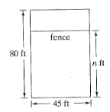

* 1. 
  2. 
  3. 
  4. 

1. Write the expression that represents each of the statements below.
   1. The product of twice a number and four increased by two
   2. The quotient of three less than a number and seven decreased by two

Simplifying, Writing, and Evaluating Expressions

Answers

1. -9
2. 
3. C
4. C
5. A.  B. 

TOPIC 2

Solving Equations

Solve each equation:

1. 
2. 
3. 
4. Solve the following equation for *y*, place your answer in the grid provided.



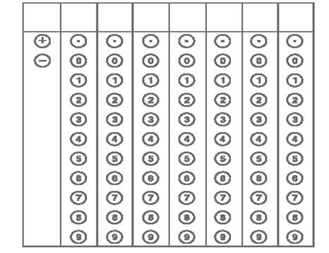

Solving Equations

Answers

1. *n* = -1.5
2. 
3. *r* = 2
4. 24 (make sure that you have bubbled the number correctly!)

TOPIC 3

Writing and Solving Equations from Real World Situations

1. Jack paid to have his motorcycle fixed at an auto-repair shop. The parts needed to do the repair cost $72, and the service fee was $12 per hour. If c represents the amount that Jack paid, write an equation to represent this situation.
2. Yesterday was your mom’s birthday. You sent her a bunch of daisies and a box of chocolates as a gift totaling $43. If the box of chocolates cost $13 and the price of a daisy was $3, how many daisies did you buy?
3. Five less than twice a number is the same as the number increased by eight. Find the number.
4. The sum of three consecutive odd numbers is 141. What is the smallest of the three numbers?
5. Karin’s mom runs a dairy farm. Last year Betty the cow gave 375 gallons less than twice the amount from Bessie the cow. Together, Betty and Bessie produced 1464 gallons of milk. How many gallons did each cow give?
6. The perimeter of a rectangular garden is 54 feet. If the length of the garden is 3 more than twice the width, what is the length of the garden?

TOPIC 4

Literal Equations

1. Solve the following equation for *y*:



1. Solve the following equation for *w*.



1. Solve the following equation for *t*.



1. Solve the following equation for *h*.



Literal Equations

Answers

1. 
2.  OR 
3. 
4. 

TOPIC 5

Solving Proportions, Percent and Percent Change

1. Next year West Jr. High will accept 350 magnet students. Of the 200 currently selected, 35% are male and 65% are female. If they want to have half the students be male and half female, how many of the students still to be selected will need to be male?
2. Write Dominic was packing 10 coffee mugs at a time into boxes to be shipped. In each box, two of the mugs say, “World’s Best Mom”. If he packs 12 boxes, how many of the mugs do not have the message?
3. If 20 percent of *m* is 30, what is 10 percent of *m*? Bubble your answer on the grid below.



1. This year the price of a bike is 20% higher than last year’s price of $150. What percent of this year’s price is last year’s price?
2. Nettie’s Nail Salon has noticed that most customers add a 20% tip to their total bill. If Nettie’s Nail Salon charges *x* dollars for a regular manicure, which one of the following equations represents, *t,* the total price, including tip most customers pay for a regular manicure?
3. *t =* 0.2(x)
4. *t =* 1.2(x)
5. *t =* .8(x)
6. *t = x +* 0.2

TOPIC 6

Solving Inequalities

1. Maggie has $20 to spend at the pet store. She buys 3 toys for $4.70 each. She also bought some doggie treats that cost $0.65 each. Write and solve the inequality that could be used to find the most number of doggie treats, *d*, that Maggie can buy.

Set up and solve the following inequalities.

1. A certain type of plant needs an average temperature between 80 and 85 degrees Fahrenheit. If the temperatures over the last 6 days have been 92, 93, 82, 86, 80 and 79. What temperature for the 7th day will allow the plant to stay healthy?
2. Corey works for a company that sells computers. When he ships the computers they each weigh 24 pounds. The box he puts the computers in weighs 12 pounds. If the entire box can weigh no more than 450 pounds, how many computers can he pack in the box? Graph your solution on the number line provided.



Solve the following inequality, then graph the solution.

1. 
2. Which of the following represents all values of *x* that satisfy the inequality below?



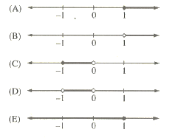

Solving Inequalities

Answers

1. 9; ( )
2. Between 48 and 83 degrees.
3. ; therefore 18 computers or less.



0 1 2 3 4 5 6 7 8 9 10 11 12 13 14 15 16 17 18

1. 



-3

TOPIC 7

Compound Inequalities

Solve the following inequalities, then graph the solution.

1. 



1. 
2. 



1. 

Compound Inequalities

Answers

1. 
2. 
3. 
4. 

TOPIC 8

Challenge

1. If the average (arithmetic mean) of *x*, 5*x*, and 6*x* is 8, what is the value of *x*?
2. 1
3. 2
4. 3
5. 4
6. 5
7. A salesperson’s commission is *k* percent of the selling price of a car. Which of the following represents the commission, in dollars, on 2 cars that sold for $14,000 each?
8. 280*k*
9. 7,000*k*
10. 28,000*k*
11. 
12. 
13. In an election, 2.8 million votes were cast and each vote was for either Candidate I or Candidate II. Candidate I received 28,000 more votes than Candidate II. What percent of the 2.8 million votes were cast for Candidate I?
14. 50.05%
15. 50.1%
16. 50.5%
17. 51%
18. 55%
19. If 3*x* = 0, what is the value of ?
20. 
21. 1
22. 
23. 7
24. 13
25. State University plans on accepting a total of 1,000 students for next year’s class. Of the 800 students accepted so far, 60 percent are female and 40 percent are male. How many of the remaining students to be accepted must be male in order for half the total number of students accepted to be male?
26. 100
27. 120
28. 160
29. 180
30. 200
31. When the number *w* is multiplied by 4, the result is the same as when 4 is added to *w*. What is the value of 3*w*?
32. 
33. 1
34. 
35. 3
36. 4

Answers:

1. B 2. A 3. C 4. B 5. D 6. E