1. Which of the inequalities below represents the second step of the solution process?

Step 1: 

Step 2:

Step 3: 

Step 4: 

1. 
2. 
3. 
4. 
5. Simplify this expression.



1. Printing a newsletter costs $1.50 per newsletter plus $450 in printer’s fees. The copies are sold for $3 each. If *x,* equals the number of newsletters sold, how many copies of the newsletter must be sold in order to make a profit?
2. 
3. 
4. 
5. 
6. If  , what is the value of x?
7. The dimensions of a rectangle are  and  . Write an expression to represent the perimeter of the rectangle in simplest form.
8. If , find the value of *r*.
9. Which of the following represents a function?



I.

II. {(10, 20), (20, 30), (30, 20), (40, 40)}

|  |  |  |  |  |
| --- | --- | --- | --- | --- |
| *x* | 20 | 30 | 40 | 30 |
| *y* | 10 | 20 | 30 | 40 |

III.

10

20

30

40

10

20

30

40

*y*

*x*

IV.

1. I and IV
2. II and IV
3. I, II and III
4. IV only
5. Radio telescopes are built in the shape of a parabola. The graph below shows the cross section of the dish of a radio telescope. Select the best answer choice that describes the domain and range of the telescope.

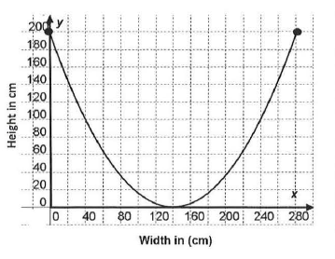

1. D: All real numbers

R: All real numbers

1. D: , R: 
2. D:  , R: 
3. D:  , R: 
4. Which of the following formulas can be used to represent the *n*th term of the geometric sequence below?

-2, -4, -8, -16, …

1. 
2. 
3. 

**D** 

1. If, then what is the value of *f*(2)?

1. Use the graph below to find the value(s) of f(*x*)=6.



1. What is the equation in standard form of the line that passes through the point (1,24) and has a slope of -0.6?
2. 
3. 
4. 
5. 
6. Line *E* passes through the point (-4, 2) and has a slope of  . Line *F* passes through the same point but is perpendicular to line *E*. Which equation represents line *F*?

**A** 

**B** 

**C** 

**D** 

1. Write an equation of a line and determine the slope of a line that passes through the point (-2, 1) and is perpendicular to the *x*-axis.
2. What is the rate of change of the function?

Solve Each System of Equations

1. 
2. 

17. 



1. 

